**Monitoring of soil fertility parameters in the area of ​​the city of Sombor at permanent control points**

Zoran Boca1, Vladimir Sabadoš2, Danijela Žunić3

1Poljoprivrednastručna služba Sombor, Staparski put 35, Sombor, Serbia [psssombor.bocazoran@gmail.com](mailto:psssombor.bocazoran@gmail.com)

**Abstract**

With the aim of long-term monitoring of soil fertility parameters, PSS Sombor carried out sampling and analysis of soil samples for five basic fertility parameters: pH value, content of humus, calcium carbonate (CaCO₃), readily available phosphorus (P₂O₅) and readily available potassium (K₂O). The area of ​​agricultural land covered by monitoring is 100,381 ha. Sampling was done at fixed points with GPS coordinates determined for each point individually. The points were selected on a cartographic basis for the area of ​​the city of Sombor through the formation of a triangulation network (according to the Delaunay method). In this way, 153 permanent points were selected where soil sampling was carried out at depths of 0-30 cm and 30-60 cm. Soil analyzes were performed in the PSS Sombor laboratory using standard methods for the given parameters. The first sampling was carried out in 2010, and the second in 2022 after 12 years. Differences compared to the previous period were observed: the pH value increased by 0.12, the CaCO₃ content increased by 1.63%, no significant difference was observed in the humus content between the two periods, the phosphorus content did not change significantly, while the potassium content increased by 11.04 mg/100gr of soil. This ten-year research indicates the necessity of systematic soil monitoring and basic fertility parameters. In the future, it is necessary to repeat this kind of monitoring at constant points in order to notice the differences that occur in a decade.

Key words: soil, fertility parameters, monitoring, control points, decade

**Introduction**

In this study of agricultural soil in the area of ​​the city of Sombor (northwestern part of Serbia), the content of macroelements and basic parameters of soil fertility was examined at depths of 0 to 30 and 30 to 60 cm, while the content of microelements and heavy metals was examined at a depth of 0 to 30 cm. Laboratory analyses of basic parameters of soil fertility were performed in the laboratory of the Agricultural Expert Service Sombor in Sombor, while analyses of the content of microelements and heavy metals were performed in the laboratory of the Institute of Field and Vegetable Crops in Novi Sad. Soil sampling was carried out at fixed points with the determination of GPS coordinates for each point individually, as can be seen from map number 1, which contains the cartographic basis for the area of ​​the city of Sombor, as well as from map number 2, which presents a triangulation network with a list of GPS coordinates of fixed points on agricultural land in the area of ​​the city of Sombor. This was first done in 2010 and 2011.

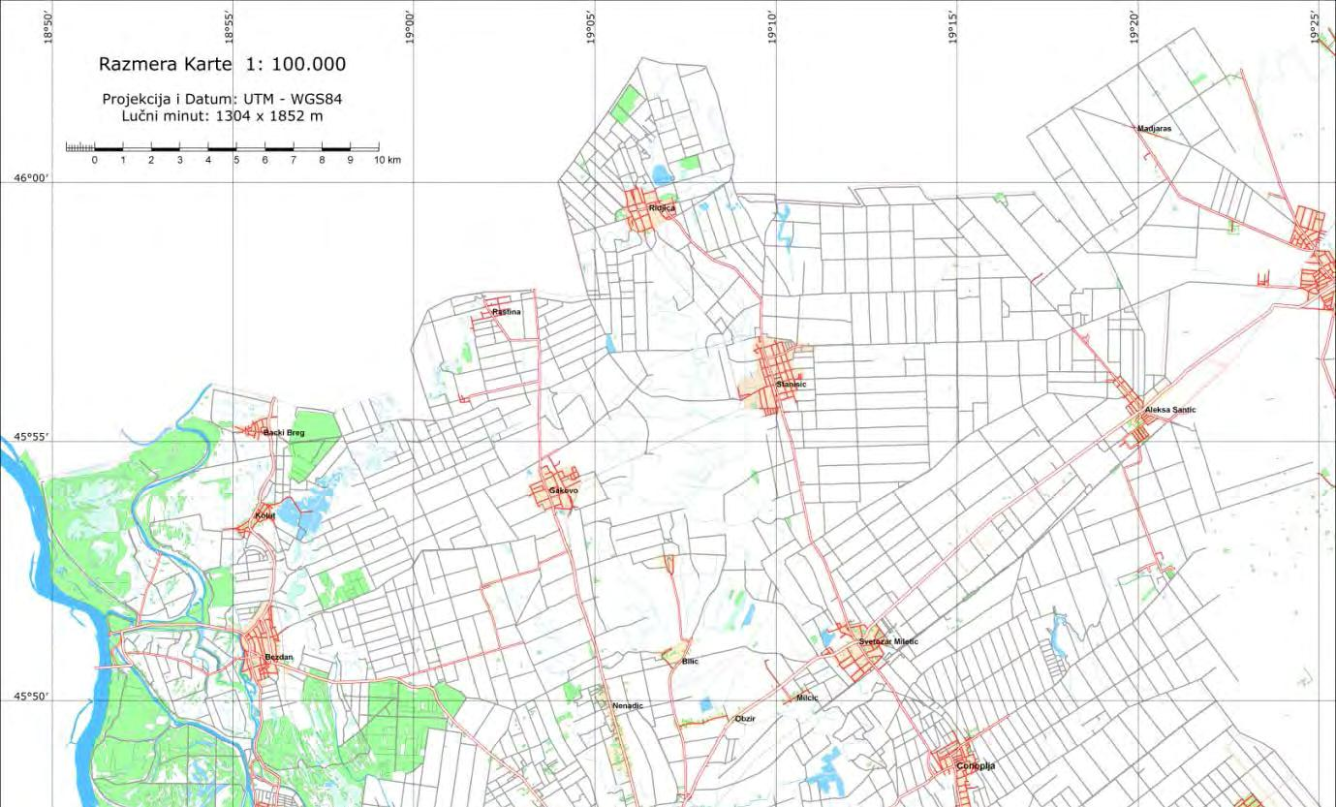After sampling and laboratory analysis of agricultural land in the area of ​​Sombor, an analysis of the obtained data was carried out, and tables and maps were created with the results of the content of macro and microelements in the land, both spatially and by types and subtypes of land, its use and ownership. Short descriptions of the importance of certain parameters of fertility for agricultural production, ways to improve those parameters, as well as measures to improve the use of agricultural land in the area of ​​the city of Sombor are also given.

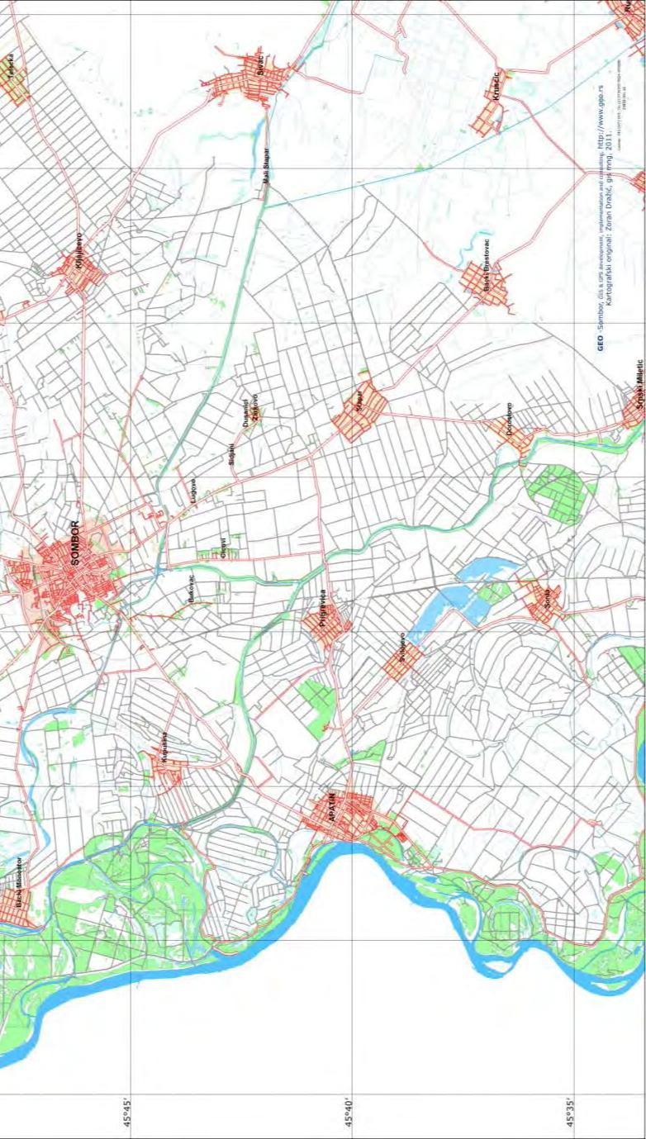

Map number 1

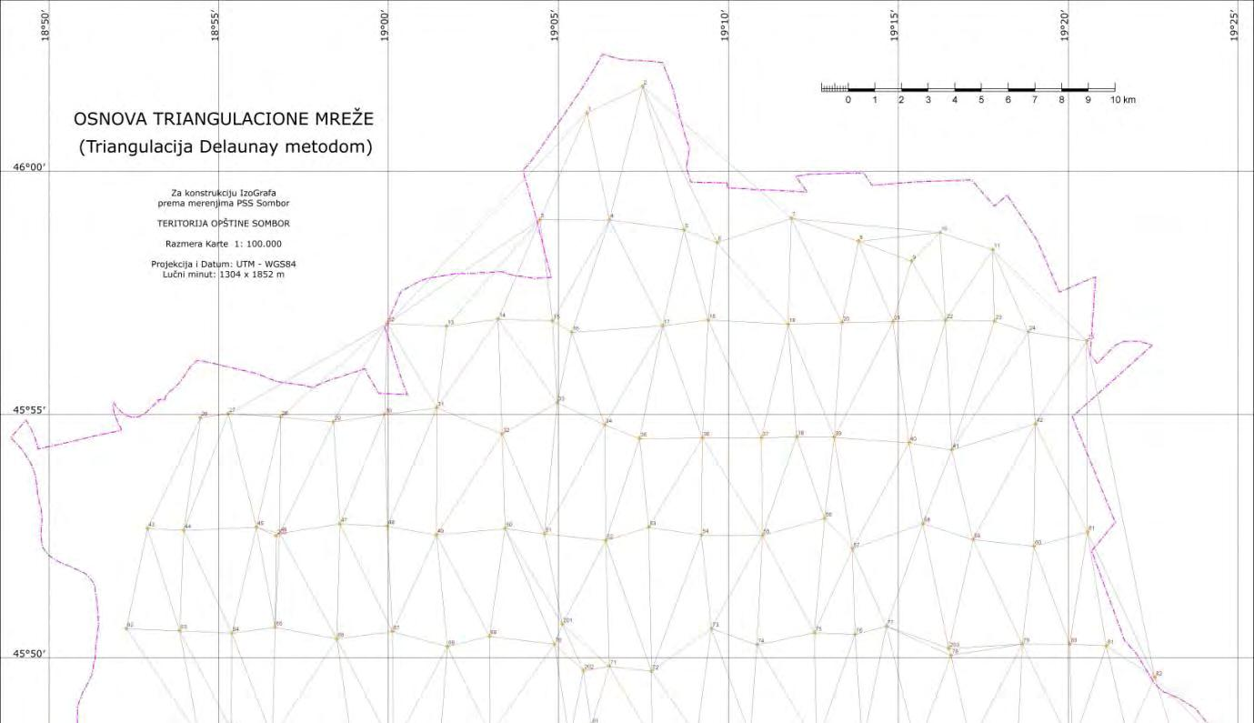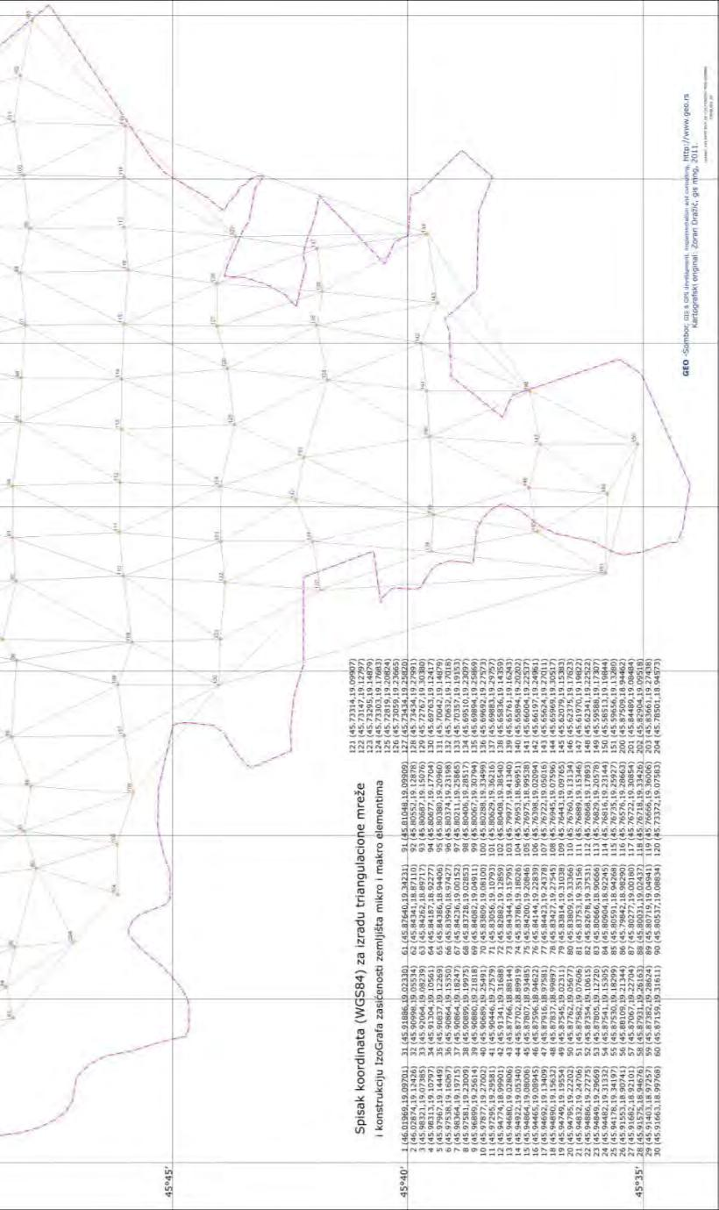

**Map number 2**

**Material and methods**

A total of 153 soil samples were taken at the same number of predetermined fixed points. Each point was determined by GPS coordinates. Although both macro and micro elements were analyzed, in this work the focus is on macro elements (readily available phosphorus and potassium) and basic fertility parameters (pH value, humus content and calcium carbonate content). The analyses were performed using standard methods. After 12 years, comparative analyses were performed by re-taking soil samples at the same points and analyzing them in the same way and with the same methods. In this sense, the results obtained are comparable.

**1. Results and discussion**

1.1. **The reaction of the soil** depends on the concentration of H+ and OH- ions. It is expressed by the pH symbol throughout the world. If the mentioned ions are in approximately the same ratio, the soil reaction is neutral. If hydrogen ions predominate, the reaction of the soil is acidic, and if the hydroxyl OH-ion predominates in the solution, the reaction will be basic. The pH value can vary in agricultural soils between 3.5 and 9.5. Neutralmsoils have a pH value of about 7. Below this value, the soil is acidic, and above it is alkaline (basic). The obtained results of the pH value of the agricultural soil (pH in 1N KCl) show that the pH values ​​are significantly higher at a depth of 30 to 60 cm compared to the depth of the arable layer from 0 to 30 cm. The number of samples with a neutral pH value was 36.54%, which would be very favorable if most of the samples (53.21%) did not belong to the group of slightly alkaline and alkaline soils, which is a concern, given that the pH values ​​have increased by 0.2 to 0.4% over the last 60 years. This data was obtained by observing the results on the same plots, and the increase in pH value is certainly a consequence of the inadequate application of agrotechnical measures in production. The mean value of the tested samples pH in KCl is 7.59 at a depth of 0 to 30 cm.

Graph number 1: *Percentage representation of examined samples of agricultural soil in the layer from 0 to 30 cm in the area of ​​the city of Sombor, according to categories of soil reaction values*

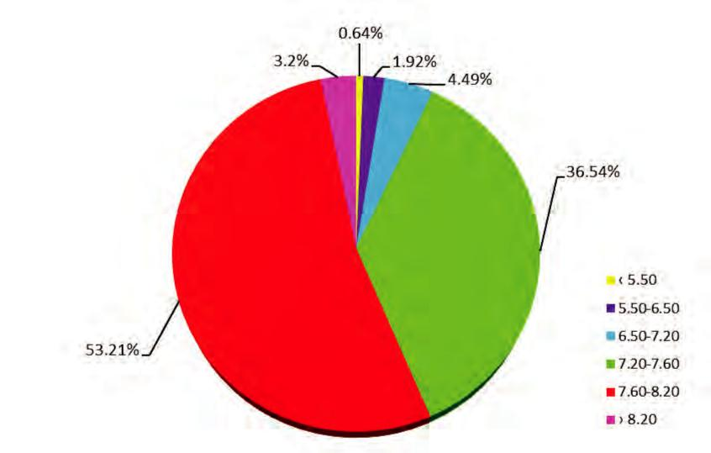

1.2. **The content of calcium (Ca) and calcium carbonate (CaCO3) in agricultural land in the area of ​​the city of Sombor**. Calcium is a very widespread element in nature, but it is found in unequal quantities in soils. There are rare soils that lack Ca (as a necessary element for the needs of plants), so it is not introduced into the soil specifically for that purpose. Plants absorb calcium from the soil solution for their needs, in the form of divalent calcium ion (Ca+2).

Calcium (in the form of CaCO3) is known to be an important factor in soil fertility, it has a favorable effect on its zygochemical properties (it is the main neutralizer of soil acidity because it acts as a buffer), and hence the agrotechnical measure of calcium cation is often applied on acidic soils. Calcium participates in the formation of Ca-humate. It is an important coagulator, improves the structure of heavy, clayey soils and participates in regulating its pH value. Finally, calcium also affects numerous biological processes in the soil. All of the above contributes to improved plant nutrition, both with calcium and other elements of mineral nutrition. It should be emphasized that Ca plays a significant role in the nutrition of humans and animals, especially cubs (formation and strengthening of the skeleton). In relation to the CaCO3 content, our soils are divided into the following categories (Hadžić et al. 2004):

1. slightly carbonated < 2% CaCO3,

2. medium carbonate 2 to 5% CaCO3,

3. carbonate 5 to 10% CaCO3,

4. highly carbonated > 10% CaCO3.

Chart number 2: *Percentage representation of tested samples of agricultural land according to categories of CaCO3 content in the layer from 0 to 30 cm in the area of ​​the city of Sombor*

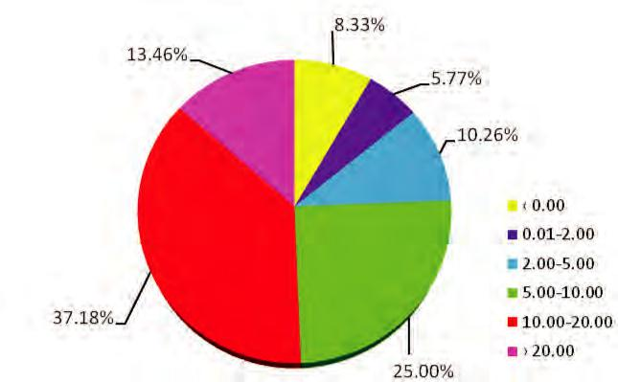

**1.3. Humus content in agricultural land in the area of ​​the city of Sombor -** Humus is a stable form of organic matter in the soil, and at the same time it is its most important form. That is why the content of humus is a particularly important indicator of soil fertility, i.e. soil biogenicity. Maintaining the humus level in the range of 3 to 5% is the most important obligation of the land user. However, in land management, this obligation is often forgotten, so the percentage of humus in the lands of Vojvodina, as well as in the lands of the city of Sombor, has decreased in the last 20 to 30 years. The reason for the decrease in humus content is primarily the increase in the share of hoeing in the sowing structure, the rapid decrease in the introduction of organic fertilizers, including harvest residues, and then the reduced introduction of mineral fertilizers, which is why plants use nutrients from soil reserves. In the area of ​​the city of Sombor, on 60.26% of the land, the humus content is above 3%. On other surfaces, the humus content is between 1 and 3%, which indicates their reduced potential fertility, which is reduced by inadequate agrotechnical measures and calls into question not only fertility, but also other important properties of agricultural land.

**Chart number 3:** *Percentage representation of examined samples of agricultural soil in the layer from 0 to 30 cm in the area of ​​the city of Sombor, according to categories of humus content*

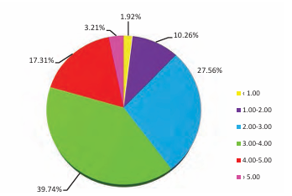

**1.4. Phosphorus content (P, P2O5) in agricultural land in the area of ​​the city of Sombor -** Phosphorus is one of the essential, constitutive and essential elements. It is important for the functioning of all living organisms because it is part of numerous organic compounds. The most important are certainly nucleic acids and nucleotides. Phosphorus participates in energy processes in plants, especially in the youngest growing parts. Most of the phosphorus in plants is in organic forms, but a smaller part is found in inorganic forms. This phosphorus serves as a reserve for plants. The total phosphorus content does not exceed 1%, and most often it is between 0.2 and 0.3%. Most phosphorus is found in the reproductive organs.

When determining phosphorus, extraction is carried out, i.e. converting the easily soluble part of phosphorus into a solution, and then the phosphorus is determined colorimetrically. Diluted Al solution is used for extraction.

Soil classification based on the content of readily available phosphorus (in mg P2O5/100 g of soil):

- 0 to 10 mg/100 g of soil - indicates poor soil

- 10 to 20 mg/100 g of soil – medium secured soil

- more than 20 mg/100 g of soil - well-supplied soil.

According to the obtained results of the agrochemical analysis of the agricultural soil in the area of ​​the city of Sombor, 35.26% of the reaserched soils belong to the group of soils poor in phosphorus, while 33.33% belong to the soil well supplied with phosphorus. Soils that contain from 25 to 50 mg/100 g of soil are classified as very well supplied with phosphorus, and 21.15% of them are in the area of ​​the city of Sombor. The toxic content of phosphorus above 50 mg per 100 g of soil was determined in 10.26% of the tested samples, at a depth of 0 to 30 cm.

Graph number 4: *Percentage representation of tested samples of agricultural soil in the layer from 0 to 30 cm in the area of ​​the city of Sombor, according to categories of phosphorus content (mg/100 g of soil)*

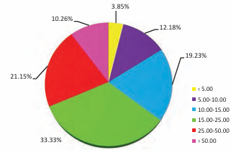

**1.5. Potassium content (K+, K2O) in agricultural land in the area of ​​the city of Sombor -** Potassium is not one of the constitutive elements, but it is necessary for all organisms. It is often de-citrated, like nitrogen and phosphorus. It is not part of any organic compound. In the plant, it is found in an ionic state in the form of various salts, and it can also be absorbed by some proteins. Because of this status, potassium can be washed out of the plant with water. The role of potassium in plants (and other living things) is not fully understood. However, it is known that its role is very important in the synthesis of sugars, transport of assimilatives, regulation of pH in the cell, photosynthesis, regulation of the water regime, etc. It affects nitrogen metabolism by supporting protein synthesis. Potassium activates various enzyme systems.

When determining potassium, extraction is performed, i.e. converting the easily soluble part of potassium into solution, and then potassium is determined flame photometrically. Diluted Al solution is used for extraction. Classification of soil based on the content of readily available potassium (in mg K2O/100 g of soil):

- poor 0 to 10 mg per 100 g of soil

- moderately supplied 10 to 20 mg per 100 g of soil

- well supplied 20 mg per 100 g of soil

- very highly secured with a content above 50 mg per 100 g of soil

According to analyzes of agricultural land in the area of ​​the city of Sombor, the potassium content is mostly sufficient. 46.15% of the areas are optimally supplied with potassium (between 15 and 25 mg/100 g of soil), while only 3.85% of the soil is poor in potassium. A high content of potassium (25 to 50 mg/100 gr) has 20.51% of the surface area, while the toxic content (above 50 mg/100 gr) is on only 1.92% of the examined samples of agricultural land in the area of ​​the city of Sombor.

**Chart number 5:** *Percentage representation of tested samples of agricultural soil according to categories of potassium content (K2O mg in 100 g of soil) in the layer from 0 to 30 cm in the area of ​​the city of Sombor*

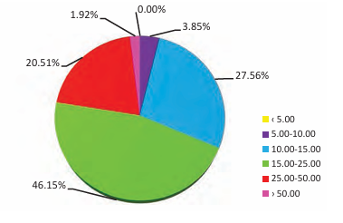

**Conclusions**

After 12 years from the first analyses, the entire procedure was repeated in order to compare the two periods. The idea is that the soil cannot be changed much, but changes have nevertheless occurred and it is therefore necessary to monitor the change in the state in the following period.

The soil pH value increased by 0.12 and the average value in 2022 is 7.71. (2010 was 7.59). It is assumed that this happened due to improper use of fertilizers and due to the period.

The calcium carbonate content increased by 1.63%. In 2010 it was 11.44% while in 2022 it was 13.07%. The chemical composition of the rocks is basically carbonate and this is probably the reason why the increase occurred.

The humus content has not changed significantly in the last 12 years. There has even been a significant increase in places where organic fertilizers are regularly applied.

The content of readily available phosphorus has not changed significantly. Soils are well supplied with phosphorus, and fertilization should be based on soil analysis.

The content of readily available potassium increased in 2022 compared to 2010, by 11.04 mg/100 g of soil. This indicates that potassium intake through fertilization is greater than what plants can extract through yield.

**References**

1. Vladimir Sabadoš, prof.dr Miroslav Malešević, prof. dr Goran Jaćimović, dr Vladimir Aćin, Danijela Žunić, Jelena Ivan, Zvonko Džeba, Olivera Sekulić, Sonja Jokić, Zoran Boca, Tatjana Veselinović, Jelena Perenčević, Josip Dekić, Vladimir Katanić . *Zemljište, poljoprivreda i ruralni razvoj* *Grada Sombora,* Editor Grad Sombor ,Poljoprivredna stručna služba „Sombor“ doo Sombor, Tampograf, Novi Sad 2019
2. Kastori, R., (2005): Azot - agrohemijski, agrotehnočki, fiziološki i ekološki aspekti. Naučni institut za ratarstvo i povrtarstvo, Novi Sad.
3. Sabadoš, V., i sar., (2004): Slana i zaslanjena zemljišta na području Sombora (mogućnost i načini korišćenja).
4. Živković, B., i sar., (1972): Zemljišta Vojvodine. Institut za poljoprivredna istraživanja Novi Sad, Novi Sad.